Parents of the two black boys

Dam:

Hale`s It All Adds Up aka Addy
​
ALAA-053237
Geburtsdatum-DOB: 01.08.2016
Größe-size: kleines medium
Farbe: apricot
Fell-coat: fleece
DNA Profil: 65583 (PawPrintGenetics
Color DNA: BBee
HD: OFA good
ED: normal
Patella Luxation: frei
Jährliche Augenuntersuchung-eyes: free
PRA: free
IC: normal
EIC: free
DM: normal
VWD: normal

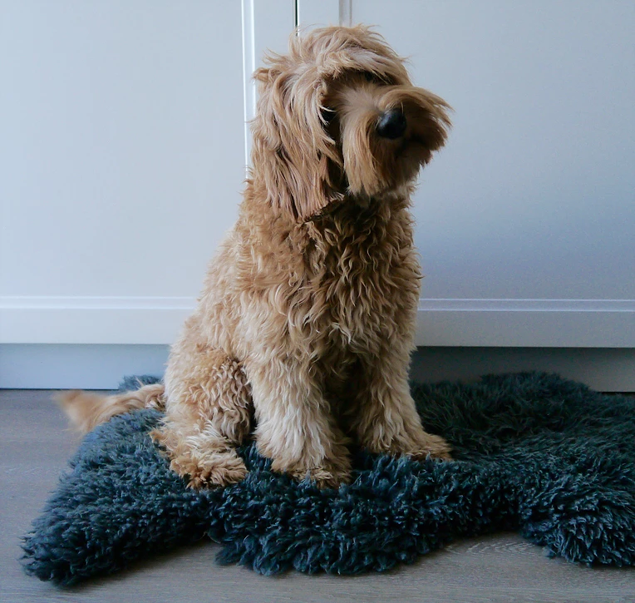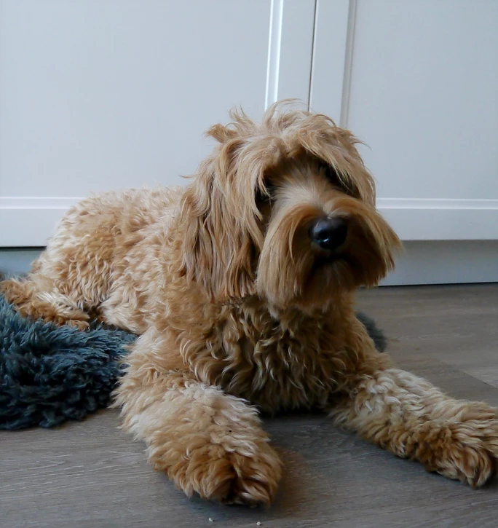

Sire:

Riverbends Hunk of Burnin' Love "Elvis"
​
​ALAA-055335
Geburtsdatum-DOB: 07.09.2016
Größe-size: 41cm
Farbe-color: parti brown/white
Fell-coat: fleece
DNA Profil: 40204 (PawPrintGenetics)
Color DNA: bbEe, KBky atat
HD: OFA good
ED: normal
Patella Luxation: free
Jährliche Augenuntersuchung-eyes: free
PRA: free
IC: free
EIC: free
DM: free

